|  |  |
| --- | --- |
| Name | Umar Hayyat |
| Roll No | 2019-EE-360 |

**Complex Engineering Problem(CEP)**

**Session 2019 Fall 2021**

**Power Distribution System**

**Circuit:**

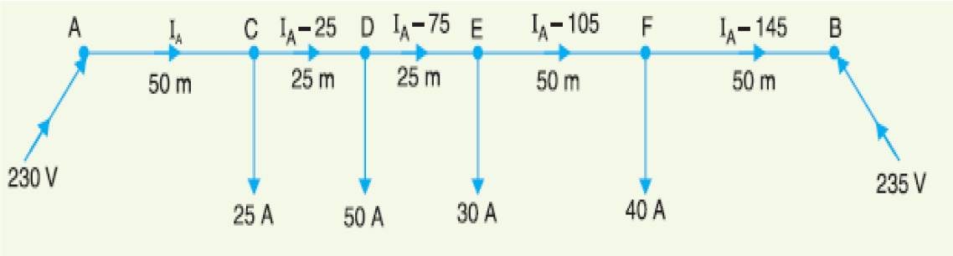**Simulation:**

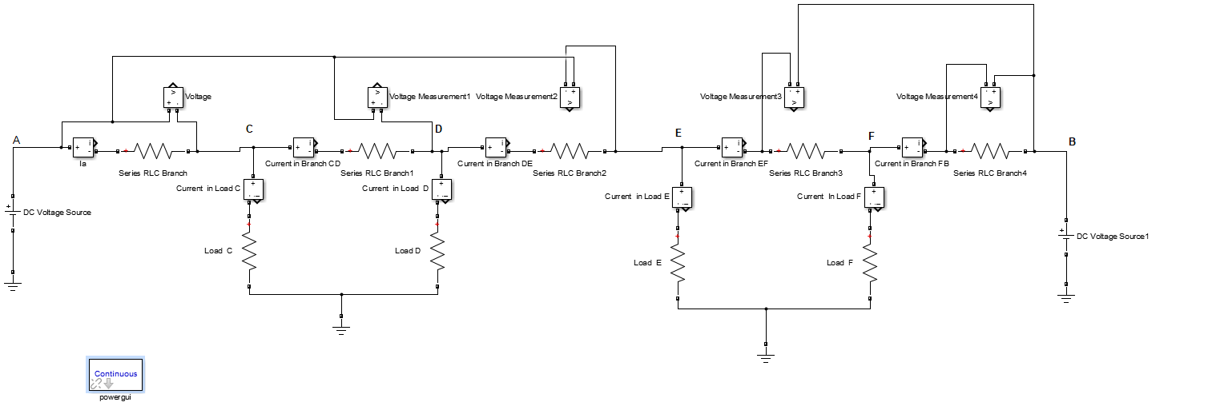

**Results:**

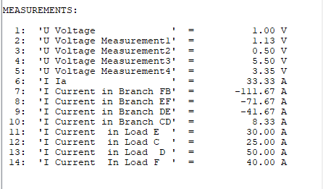

**Calculation:**

Resistance of 2 wires of 1k m length = 2 * 0·3 = 0·6 Ω

Resistance of branch AC $=0.6\left(\frac{50}{1000}\right)=0.03 Ω$

Resistance of branch CD = $0.6 \left(\frac{25}{1000}\right)=0.015 Ω$

Resistance of branch DE = $0.6\left(\frac{25}{1000}\right)=0.015 Ω$

Resistance of branch EF = $0.6\left(\frac{50}{1000}\right)=0.03 Ω$

Resistance of branch FB = $0.6\left(\frac{50}{1000}\right)=0.03 Ω$

**Voltage drops using Exact Method**

V**B** = VA – (IA*RAC + (IA − 25)* RCD + (IA − 75)* RDE + (IA − 105)* REF  + (IA − 145)* RFB)

Put values of VA , VB , RAC , RCD , RDE , REF and RFB in Equ

235 = 230 – (0.03 IA + 0.015 (IA − 25) + 0.015 (IA − 75) + 0.03 (IA − 105) +0.03 (IA − 145))

235 = 230 – (0.12 IA – 9)

IA

IA

IAC = IA = 33.34 A

ICD = IA − 25 = 33.34 − 25 = 8.34 A

IDE = IA − 75 = 33·34 − 75 = − 41.66 A

IEF = IA − 105 = 33·34 − 105 = −71.66 A

IFB = IA − 145 = 33·34 − 145 = − 111·66 A

Voltage at point C = VC = VA – IARAC =

Voltage at point D = VD = VA – (IAC RAC + ICD RCD)

VD

VD=

VD

Voltage at point E = VE = VB – (IBF RFB + IFE REF)

VE

VE  = 229.5

Voltage at point F = VF = VB – IBFRFB

VF

VF = 231.65

Voltage drop of C = VA – VC = 230 – 228.998 = 1.002

Voltage drop of D = VA – VD = 230 – 228.875 = 1.125

Voltage drop of E = VB – VE = 235 – 229.5 = 5.5

Voltage drop of F = VB – VF = 235 – 231.65 = 3.35

**Voltage drop by using approximate method**

Voltage drop VD = IR

VDC = 25*0.03

VDC = 0.75V

VDD = 50*(0.03 + 0.015)

VDD = 2.25V

VDE = 30*(0.03 + 0.03)

VDE = 1.8V

VDF = 40*0.03

VDF = 1.2V

Total voltage drop b/w pointA and B is:

∑VD = VDC + VDD + VDE + VDF

∑VD = 0.75 + 2.25 + 1.8 + 1.2

∑VD = 6V

**Comparision:**

|  |  |  |  |
| --- | --- | --- | --- |
|  | **Approximate method** | **Exact method** | **Simulation result** |
| **VDC** | 0.75V | 1.002V | 1V |
| **VDD** | 2.25V | 1.125V | 1.13V |
| **VDE** | 1.8V | 5.5V | 5.5V |
| **VDF** | 1.2V | 3.35 | 3.35V |

The values of voltage drop are same as I calculated by using exact method are same as simulated. So, simulation use exact method.